SF.SmokeTestScripts_TC_SF_OBRequiredFieldsOnSalesStage_Instance1_12-Apr-2017_10-02-31_PM_Invoke_Application.png



SF.SmokeTestScripts_TC_SF_OBRequiredFieldsOnSalesStage_Instance1_12-Apr-2017_10-02-42_PM_Login.png

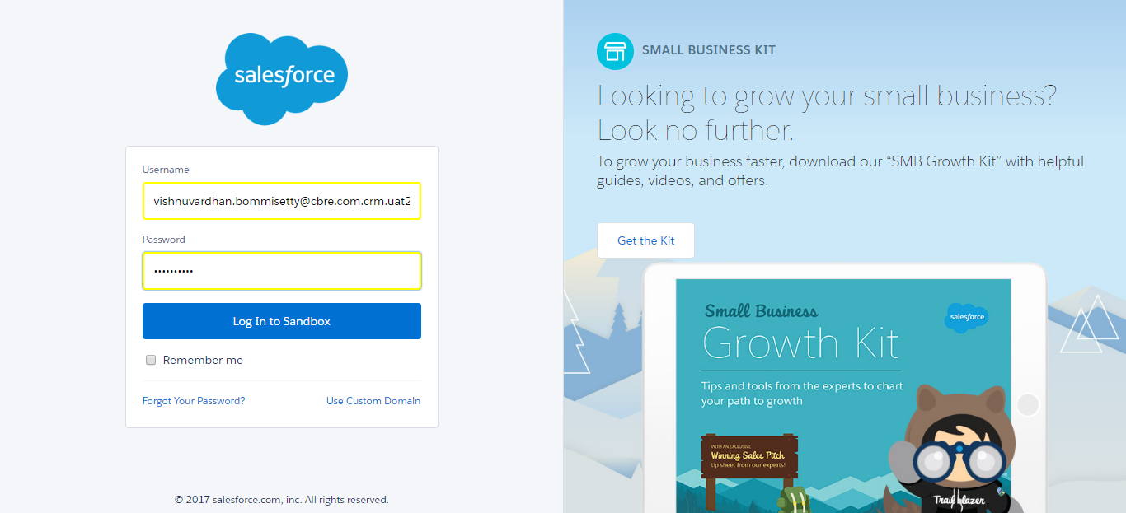

SF.SmokeTestScripts_TC_SF_OBRequiredFieldsOnSalesStage_Instance1_12-Apr-2017_10-02-57_PM_Verify_Login.png

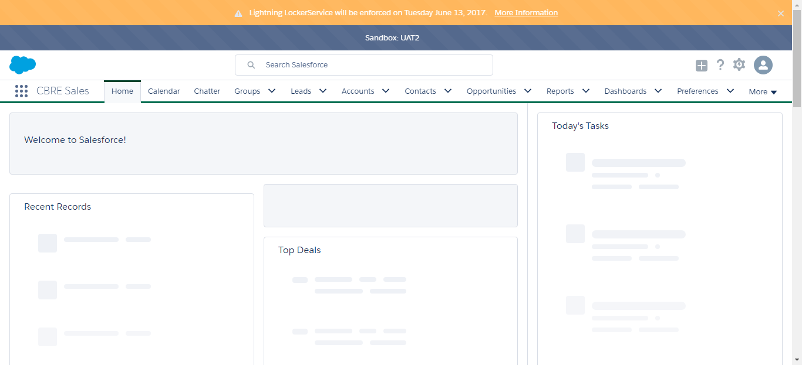

SF.SmokeTestScripts_TC_SF_OBRequiredFieldsOnSalesStage_Instance1_12-Apr-2017_10-03-01_PM_Verify_Fetch_Record.png

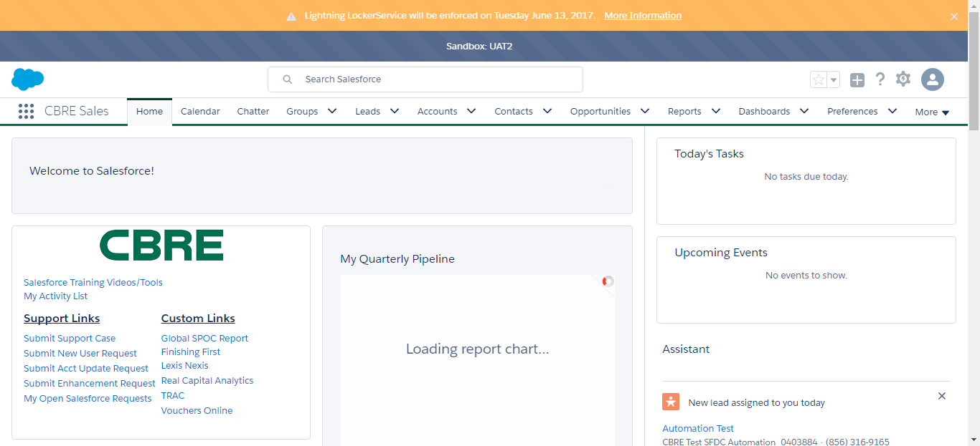

SF.SmokeTestScripts_TC_SF_OBRequiredFieldsOnSalesStage_Instance1_12-Apr-2017_10-03-05_PM_Verify_Add_Opportunity_Page

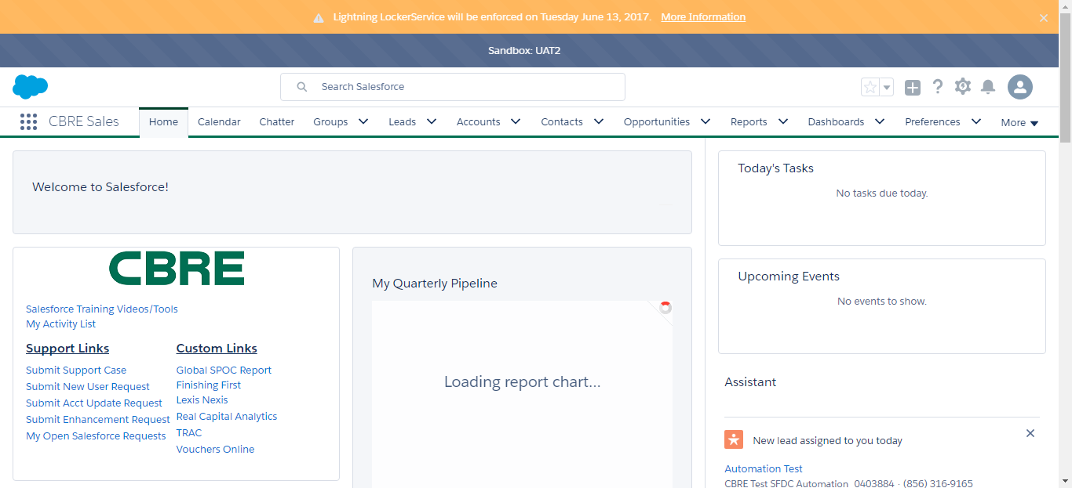

SF.SmokeTestScripts_TC_SF_OBRequiredFieldsOnSalesStage_Instance1_12-Apr-2017_10-03-05_PM_Verify_Opportunity_Required

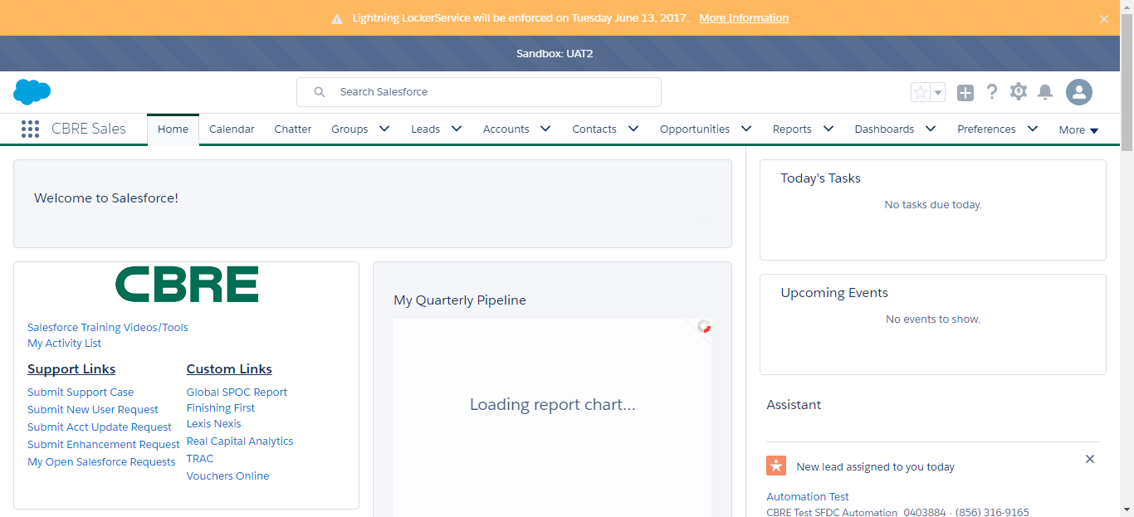

SF.SmokeTestScripts_TC_SF_OBRequiredFieldsOnSalesStage_Instance1_12-Apr-2017_10-03-22_PM_Verify_Add_Opportunity_Page

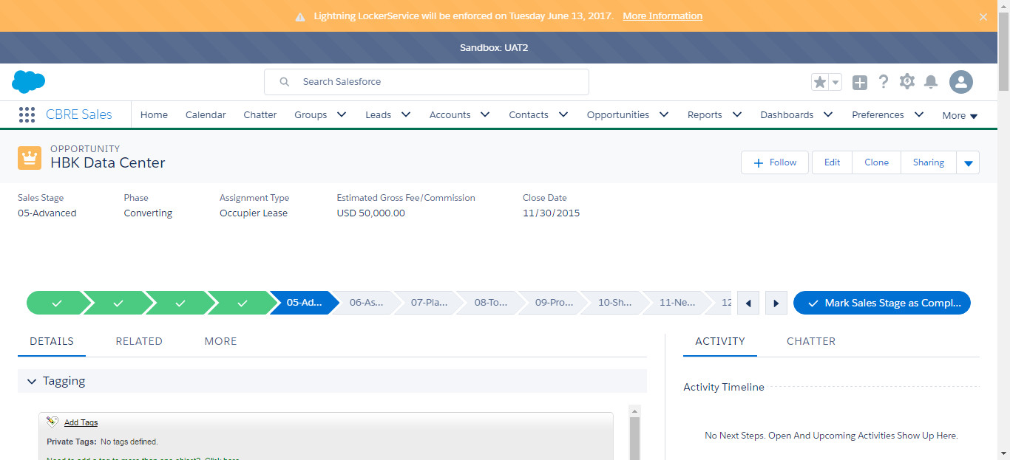

SF.SmokeTestScripts_TC_SF_OBRequiredFieldsOnSalesStage_Instance1_12-Apr-2017_10-03-40_PM_Error.png

